**Neppatrsrev Coffee app concept**

**By: Mohamed Leevan Ahmed (21449008)**

**Screen 1 (Home Screen):**

This is the main screen of the app. This screen will contain buttons for accessing menu, loyalty card screen, Store locator, Ordering and cart.



Neppatsrev Coffee

**Welcome to Neppatsrev Coffee!**



Order

Find a store

Loyalty Card

**Screen 2 (Menu) :**

This screen will display all available drinks and food items. Every item will have an image description of what it contains and price. Customers will be able to access customization screen by tapping on an item. Food and drinks will further be categorized for convenient navigation.



Neppatsrev Coffee

Menu

< Back

Beverages

Latte



Espresso with steamed milk

$3.50



Espresso with equal parts steamed milk and foam

Cappuccino

$3.75

Matcha Latte

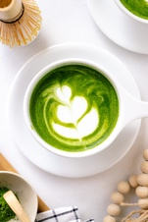

Matcha with steamed milk

$4.25

Hot Chocolate



Steamed milk with chocolate syrup

$4.00

**Screen 3 (DrinkCustomization) :**

Customization will allow customers to remove or add extras to and from items. Options will include adjusting milk, spice level, adding sugar and sizes of items, to name a few. After customization users can add the item to cart and open cart or go back to menu.



Neppatsrev Coffee

Customize Cappuccino

< Menu

Edit your Cappuccino : )

Medium

Large

Small

Fresh Milk

Almond Milk

+

--

Sugar: 0

+

Shots: 0

--

Add to cart

**Screen 4 (FoodCustomization) :**

Customization will allow customers to remove or add extras to and from items. Options will include adjusting milk, spice level, adding sugar and sizes of items, to name a few. After customization users can add the item to cart and open cart or go back to menu.



Neppatsrev Coffee

Customize Avocado Sandwich

< Back

Edit you Avocado Sandwich : )

+

--

Tomato: 0

+

--

Lettuce: 0

+

--

Cheese: 0

Add to cart

**Screen 5 (Cart) :**

This screen will show all the current items In the cart. Customers can add or remove items. The cart screen will also allow customers to proceed to checkout.

🡨

Checkout

Cart

Latte (Size: M, Milk: Almond Milk, Sugar: 0, Shots 0)

Quantity: 1

Clear

Total: $3.50

**Screen 6 (Checkout) :**

Checkout will handle finalizing payment including payment methods and total price of order. Customer should be able to enter their name and phone number.

< Cart

Checkout

Latte (Size: M, Milk: Almond Milk, Sugar: 0, Shots 0)

Quantity: 1

Total: $3.50

Name

Phone Number

Credit Card Number

Expiration Date

CVV

Total Price: $3.50

Confirm Order

**Screen 7 (Loyalty Card) :**

This screen will display the user's loyalty card information. Loyalty card screen will contain a barcode, the member’s name and the number of Neppatsrev coffee the member has consumed. Customer can navigate back to home screen.



Neppatsrev Coffee

Loyalty Card

Loyalty Card

< Back

< Back

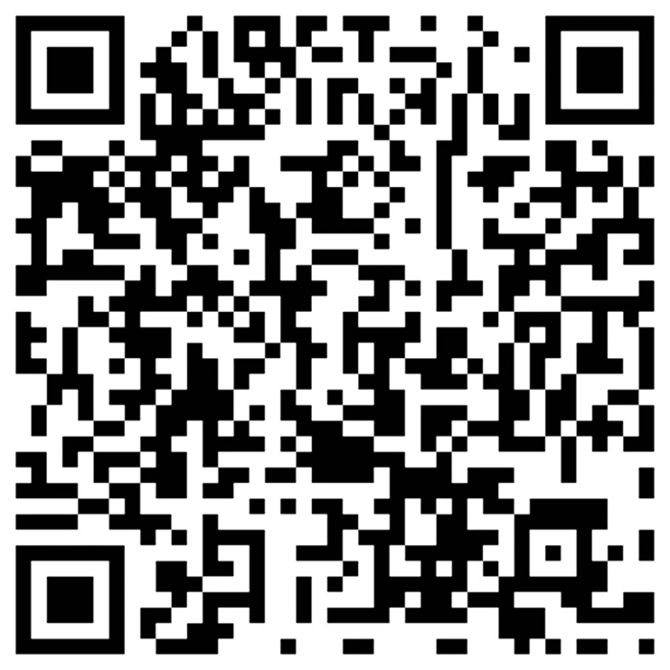

Member: Mohamed Leevan

Coffee Consumed: 5

**Screen 8 (Find a store) :**

Store Locator will help users find Neppatsrev Coffee stores near their location.It will include a clickable map of all 4 locations of Neppatsrev Coffee stores. Note that in the actual screen the map will be interactive and the map will fill the entire screen.

Neppatsrev Coffee

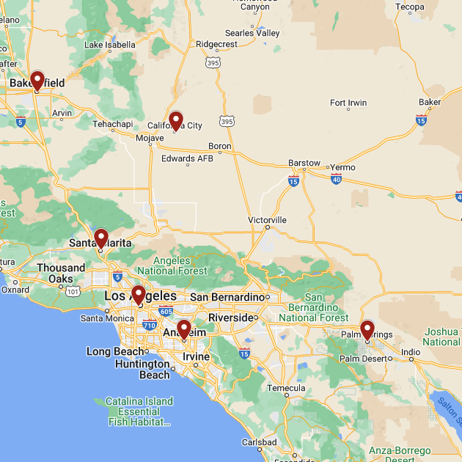

< Back

**Ipad view:**

**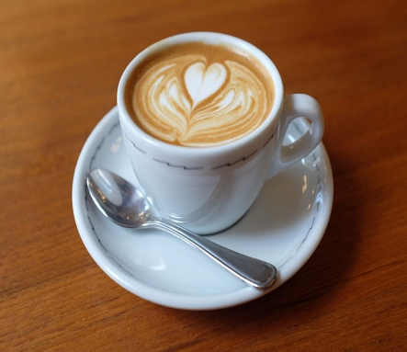****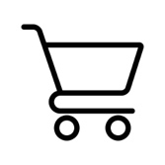**To modify the design by targeting for an Ipad view I would add more details to the description and make the images larger. I would also add a carousel to the main screen to show the latest promotions and discounts. Additionally, I would modify the menu such that options are viewable as a list or as a grid. This would make navigation through the menu more convenient.

$3.75

Espresso with equal parts steamed milk and foam with preferred amount of sugar and shots

Cappuccino

$3.50

Espresso with steamed milk with preferred amount of sugar and shots

Latte

Beverages

Menu

< Back

Neppatsrev Coffee